The Viener process and the GBM, Derivations and simulations

Marco Pasciullo

2094810

1. **INTRODUCTION**

The Wiener Process and Geometric Brownian Motion (GBM) are foundational concepts in mathematical finance and stochastic calculus. This research paper aims to explore these processes, provide derivations of their key properties, and conduct simulations to illustrate their behavior.

1. **WIENER PROCESS**

The Wiener Process, also known as Brownian Motion, is a continuous-time stochastic process that exhibits random and unpredictable movement. It has several key properties:

1. **Stationary Increments:** Increments of the Wiener process is stationary, meaning that the distribution of the increment depends only on the length of the time interval, not on its starting point.
2. **Independent Increments:** Increments over non-overlapping intervals are independent.
3. **Gaussian Increments:** Increments follow a Gaussian distribution.

**2.1) Derivation of Wiener Process Properties**

**Stationary and Independent Increments:**

The stationarity and independence of increments can be derived using the properties of normally distributed variables and limits.

**Gaussian Increments:**

The Gaussian nature of increments can be derived from the Central Limit Theorem applied to independent, identically distributed random variables.

1. **GEOMETRIC BROWNIAN MOTION (GBM)**

GBM is a continuous-time stochastic process widely used in finance to model the dynamics of asset prices. It is defined by the stochastic differential equation:

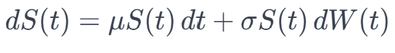

Where:

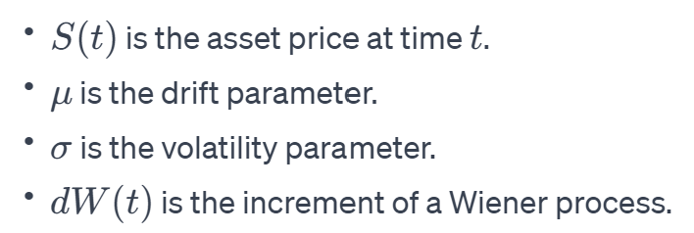

**3.1) Derivation of GBM Properties**

Solution to the Stochastic Differential Equation (SDE):

Solving the SDE using Itô's Lemma yields the solution:

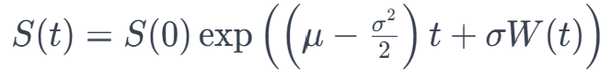

Log-Normal Distribution:

The logarithm of a GBM process follows a normal distribution, resulting in the log-normal distribution for ***S*(*t*)**.

1. **SIMULATION**

To bridge theory with practice, this thesis employs simulations to bring these processes to life. Monte Carlo simulations are utilized to generate sample paths, offering a practical understanding of the randomness and unpredictability embedded in the Wiener process. Similarly, simulations of GBM showcase its effectiveness in modeling dynamic systems, particularly in the context of predicting financial asset prices.

As we compare and contrast the Wiener process and GBM, we unveil their unique strengths and applications. While the Wiener process excels in capturing continuous random movements, GBM’s incorporation of trend and volatility proves invaluable in financial scenarios. Understanding these distinctions is crucial for students and researchers alike, providing a solid foundation in both theoretical derivations and practical simulations.

1. **CONCLUSION**

In conclusion, this thesis serves as a concise exploration of the Wiener process and GBM, emphasizing their derivations and applications through simulations. By combining theoretical insights with practical examples, we aim to provide a comprehensive understanding of these stochastic processes, making them accessible and relevant in the context of statistical courses and financial modeling.